|  |
| --- |
| CS 524 Introduction to Cloud Computing |
| Dharmit Viradia |
| Lab Assignment 2 |
| Prof. Igor Faynberg |

**Step for Creating an Amazon EC2 Instances (Using AWS Command Line Interface)**

* First step in creating instances using command line interface is to download and install it.

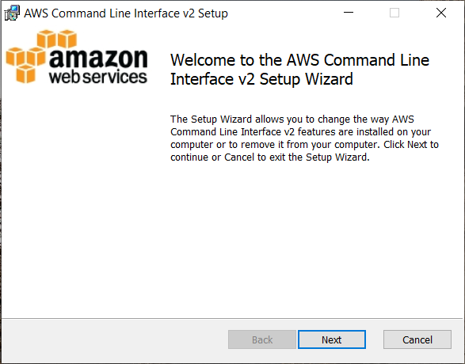 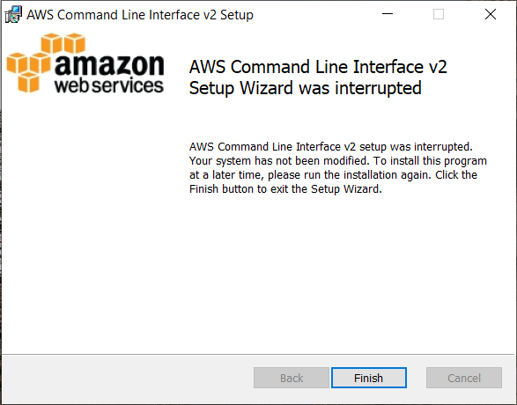

* Login to AWS Educate Account

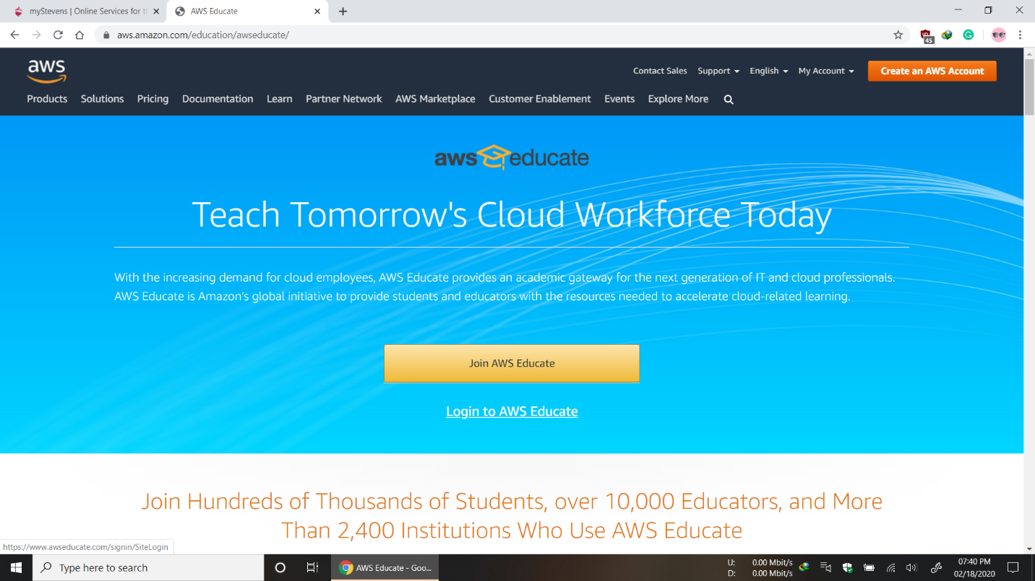

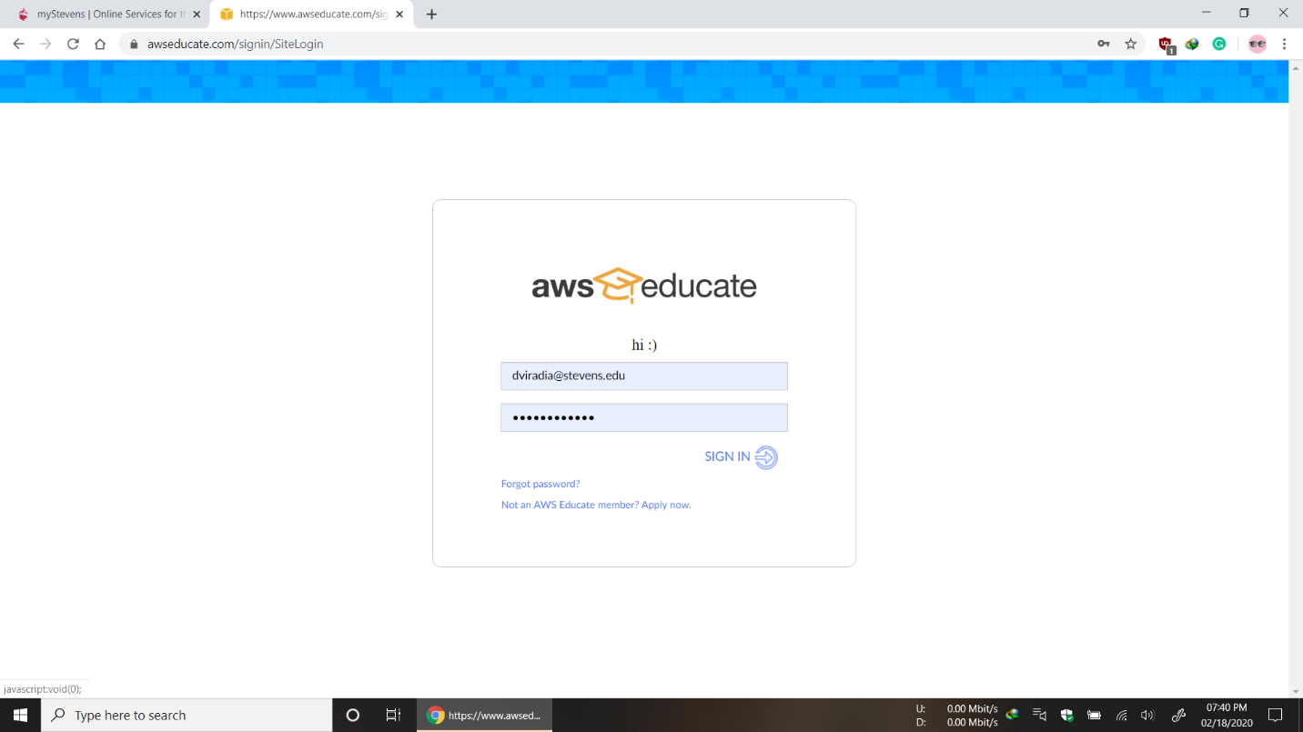

* Go to AWS Account

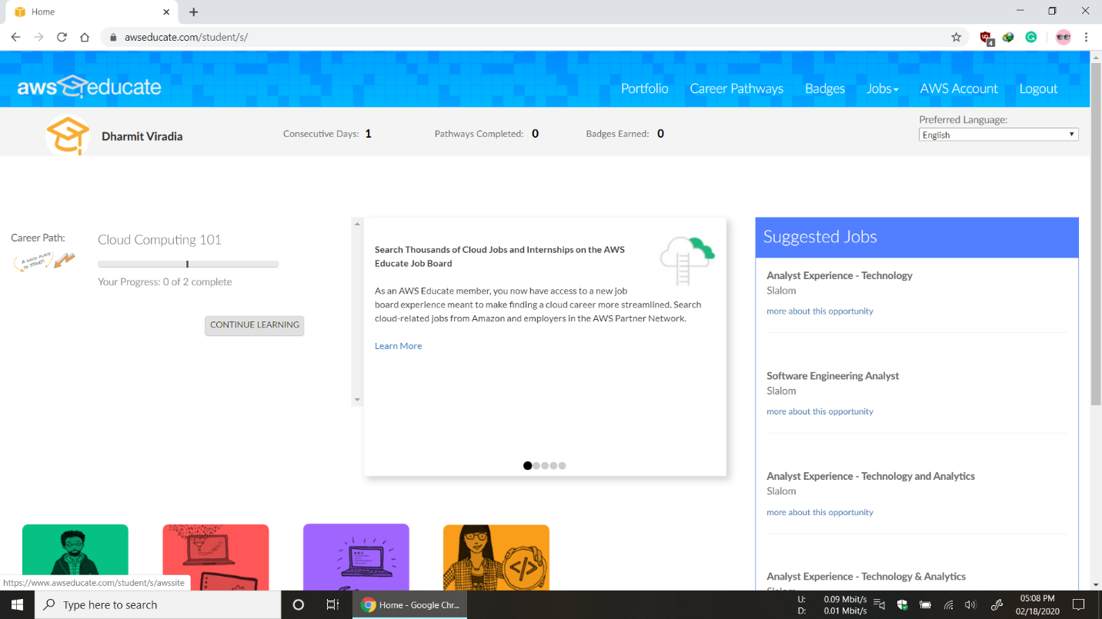

* Copy Account CLI Details to Use AWS Command Line Interface

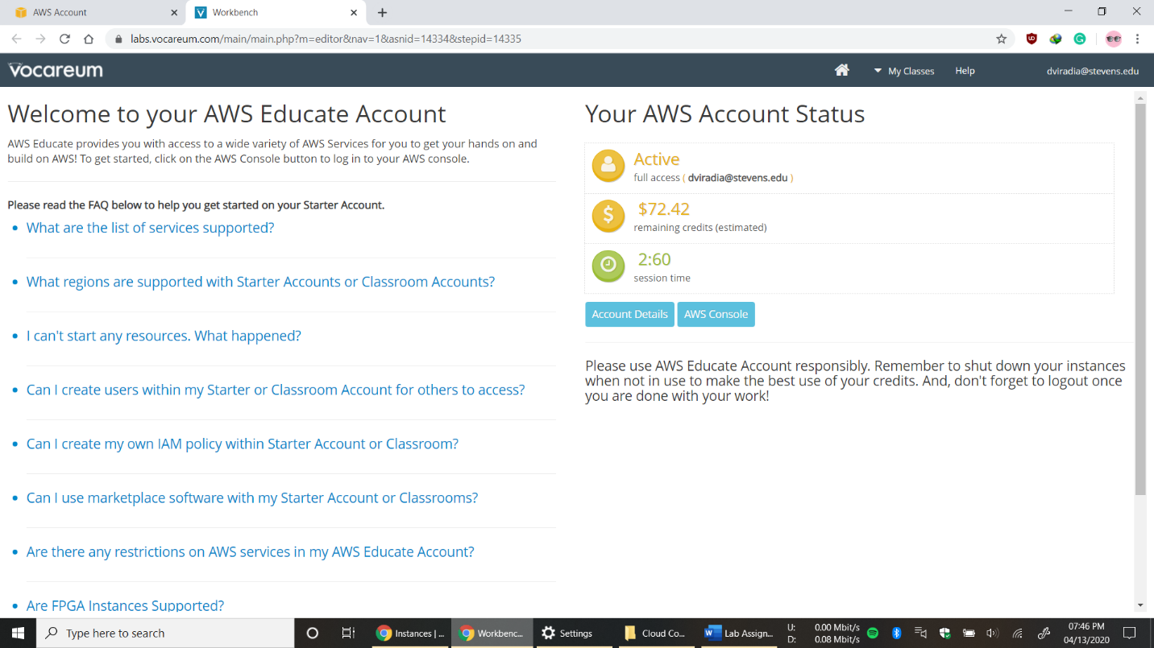

* Copy and Paste the following into ~/.aws/credentials

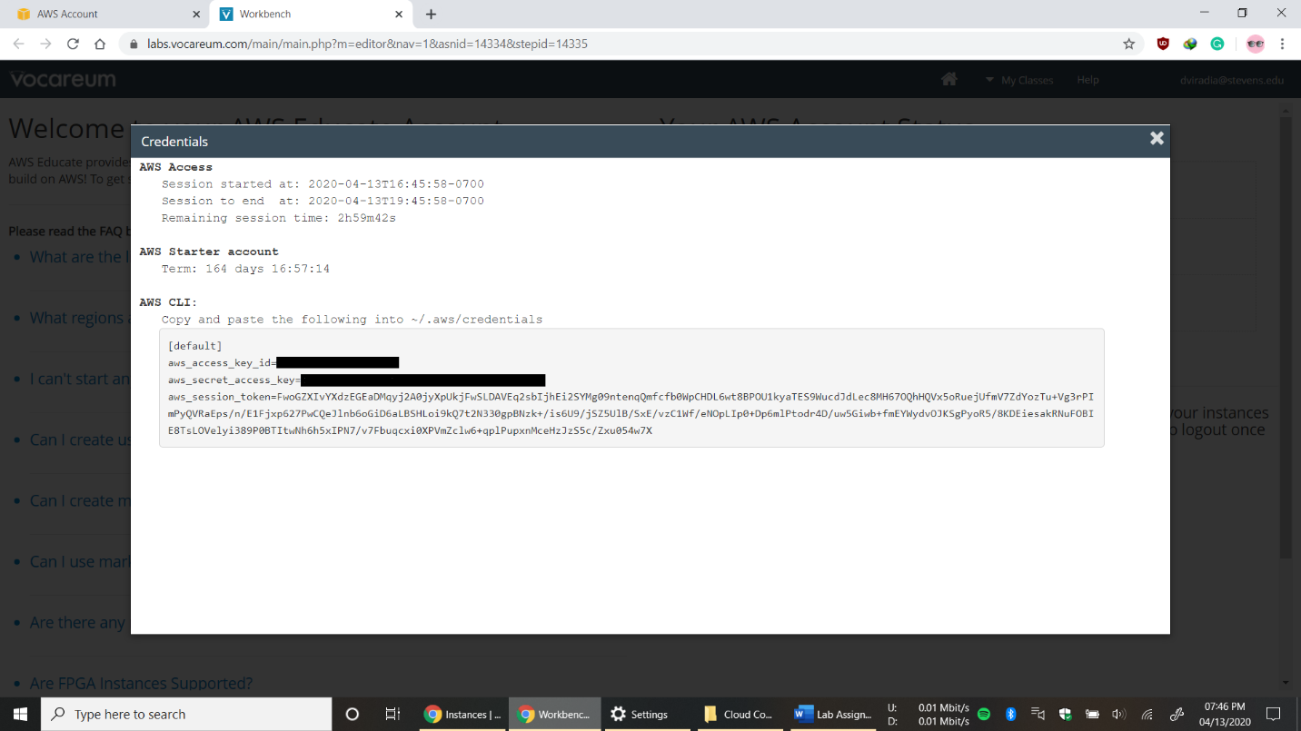

* Launch Virtual Machine

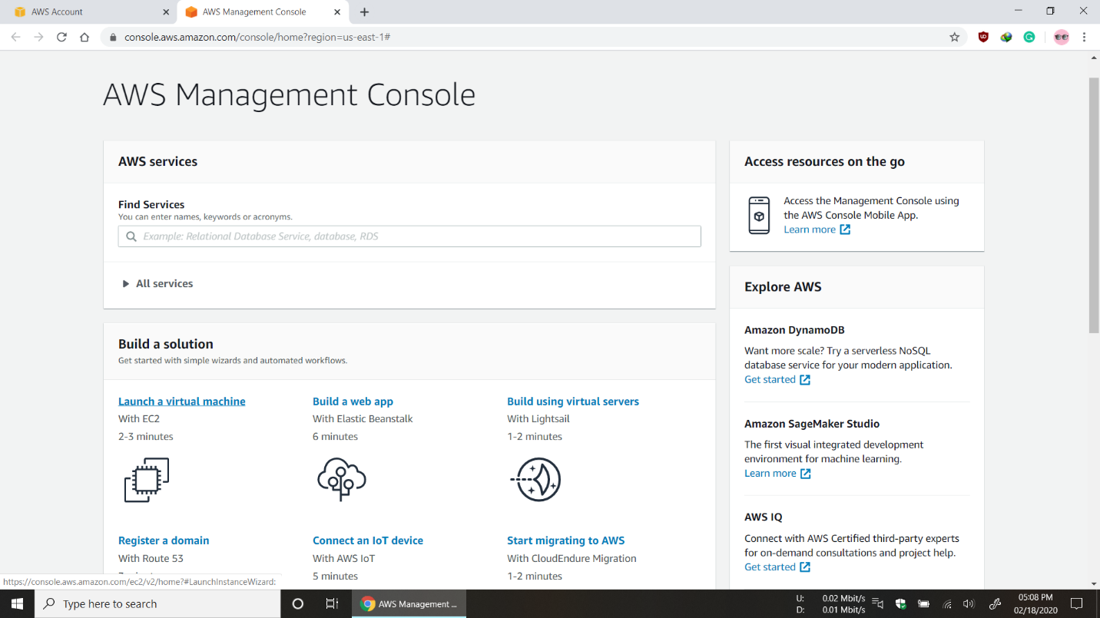

* Select Amazon Linux AMI

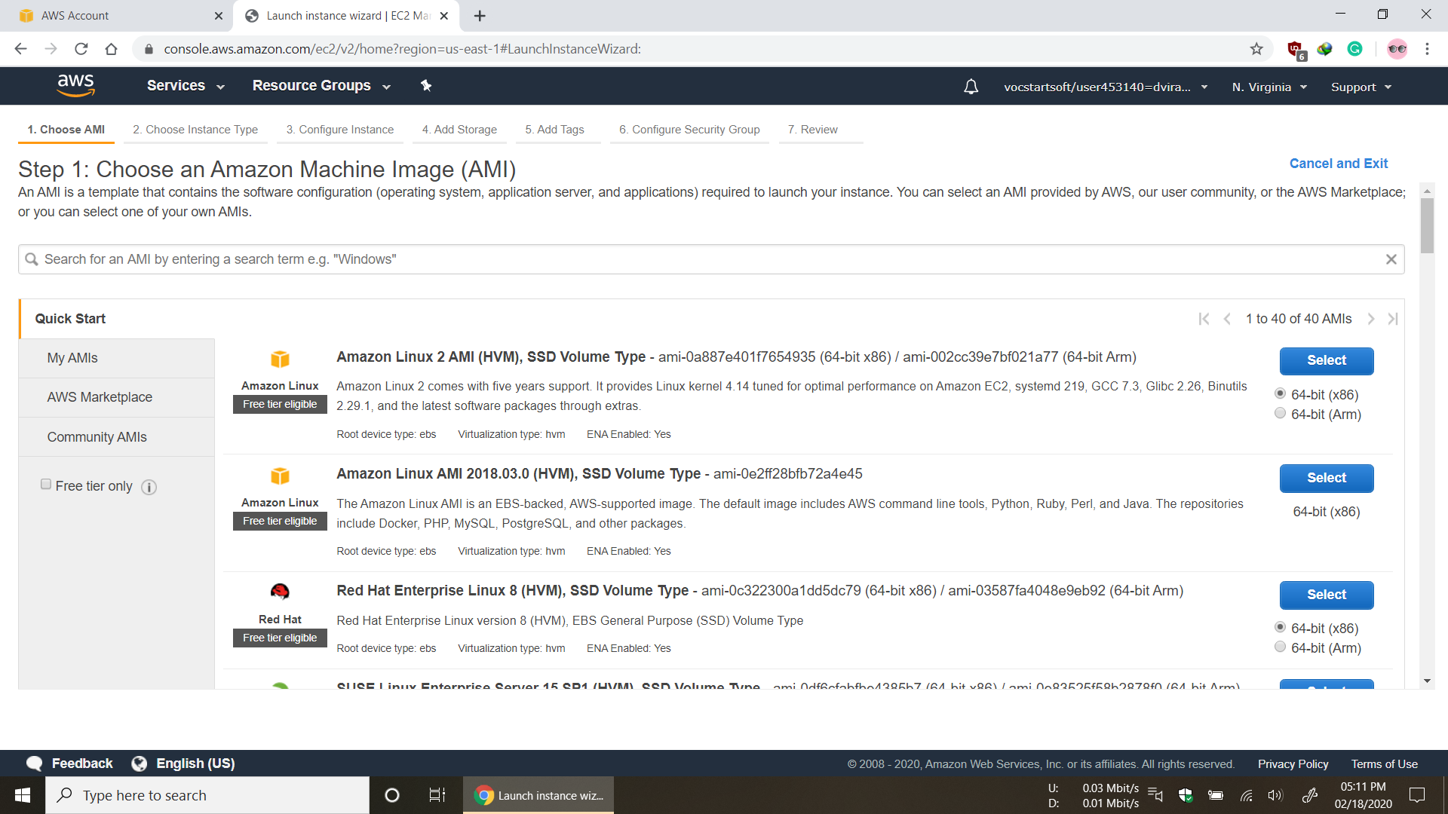

* Select Type t2.micro and review and launch

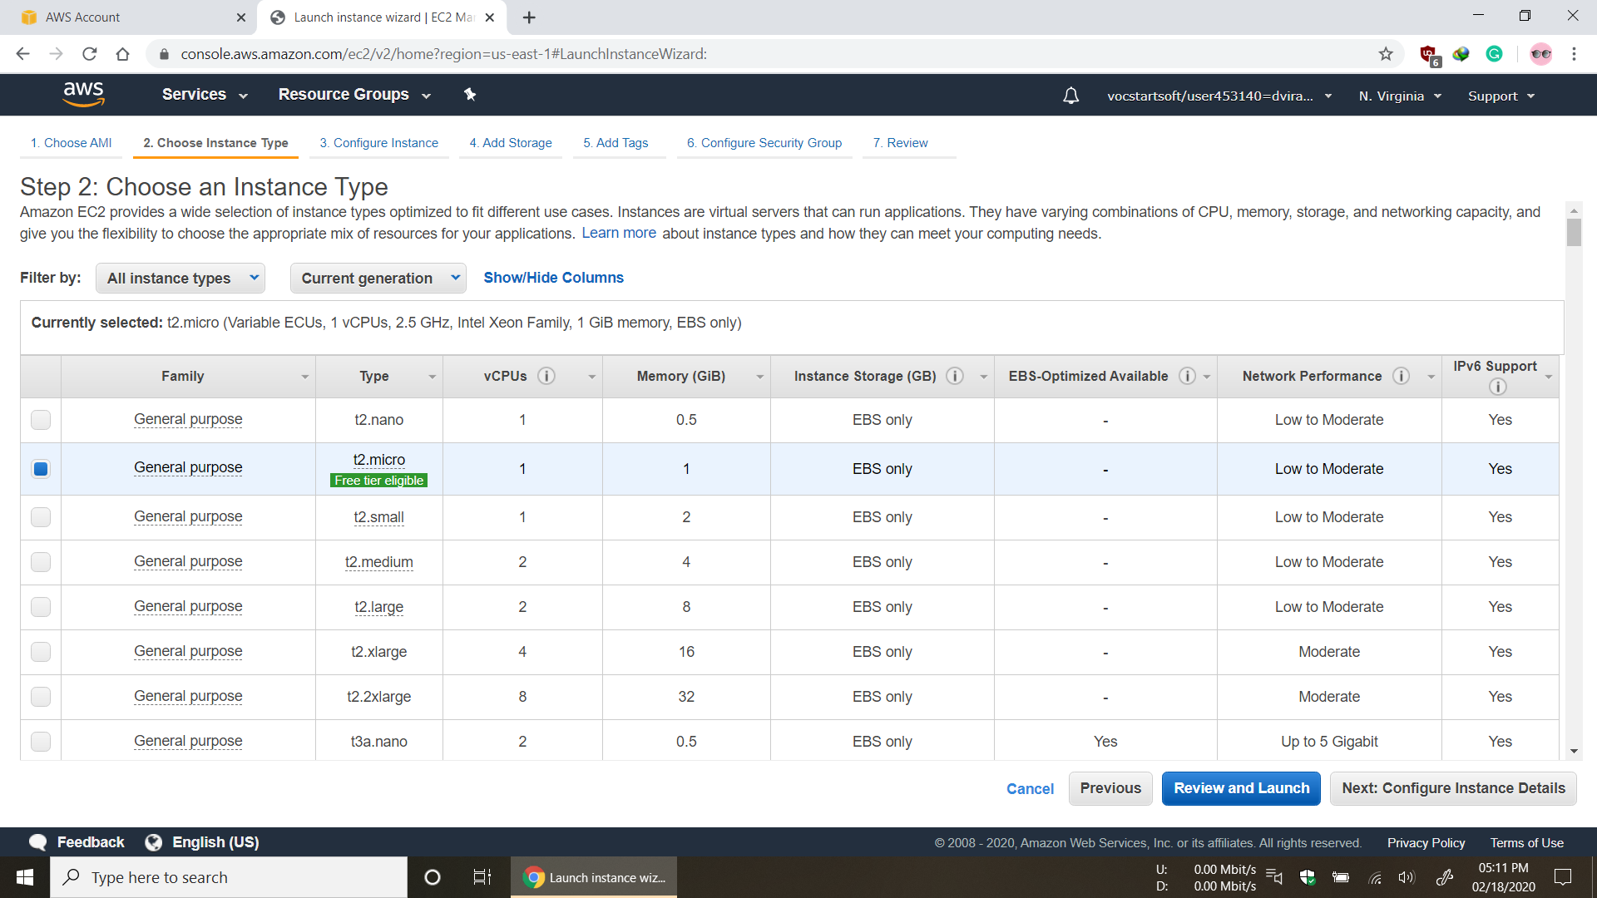

* Launch EC2 Instance

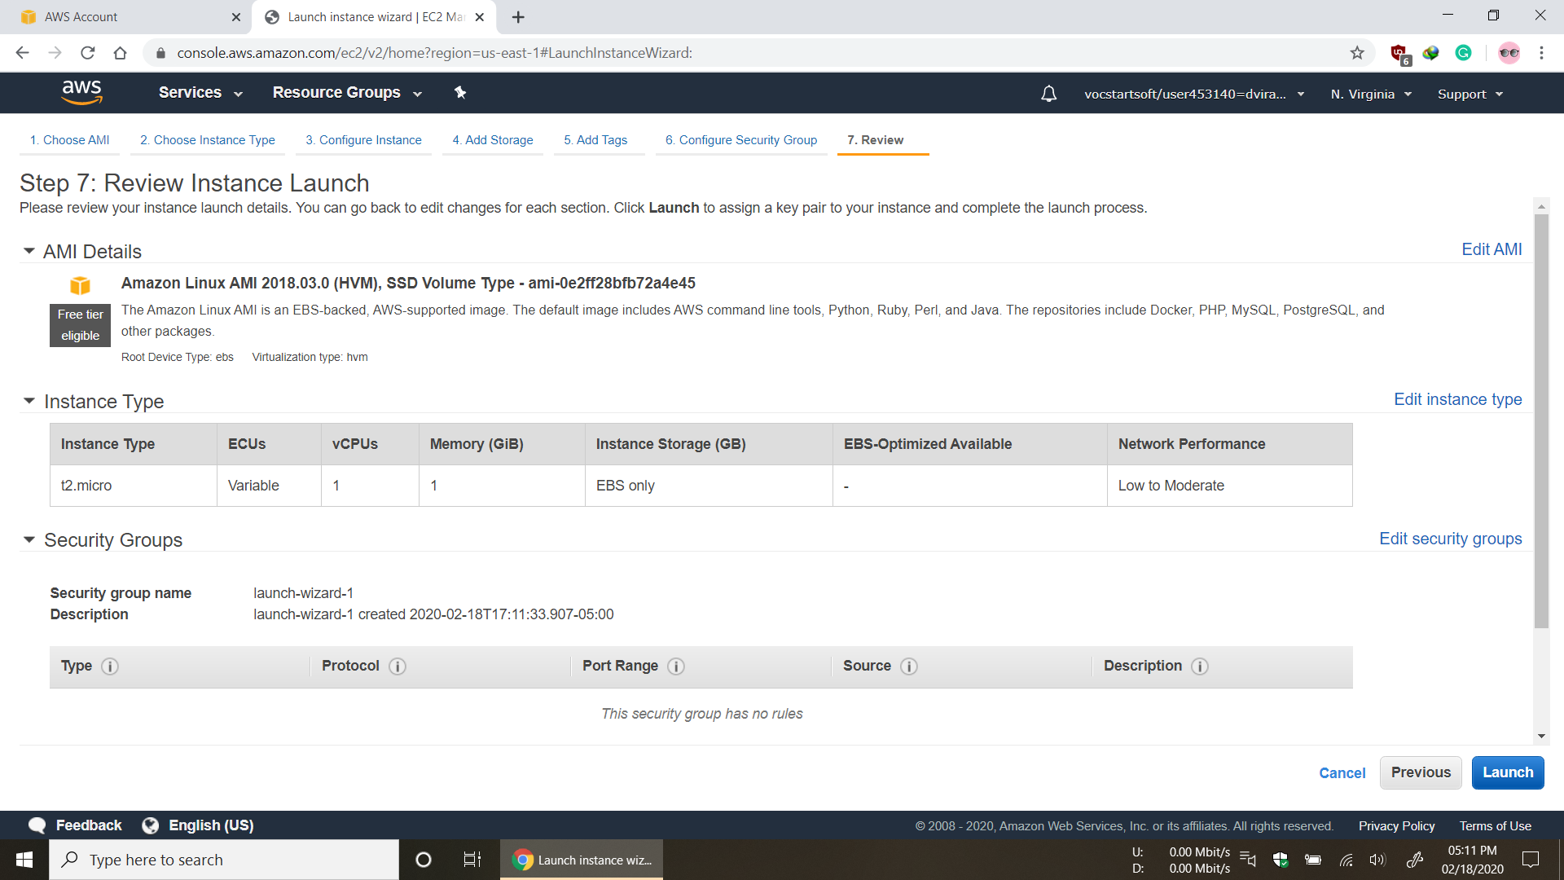

* Create Key Pair

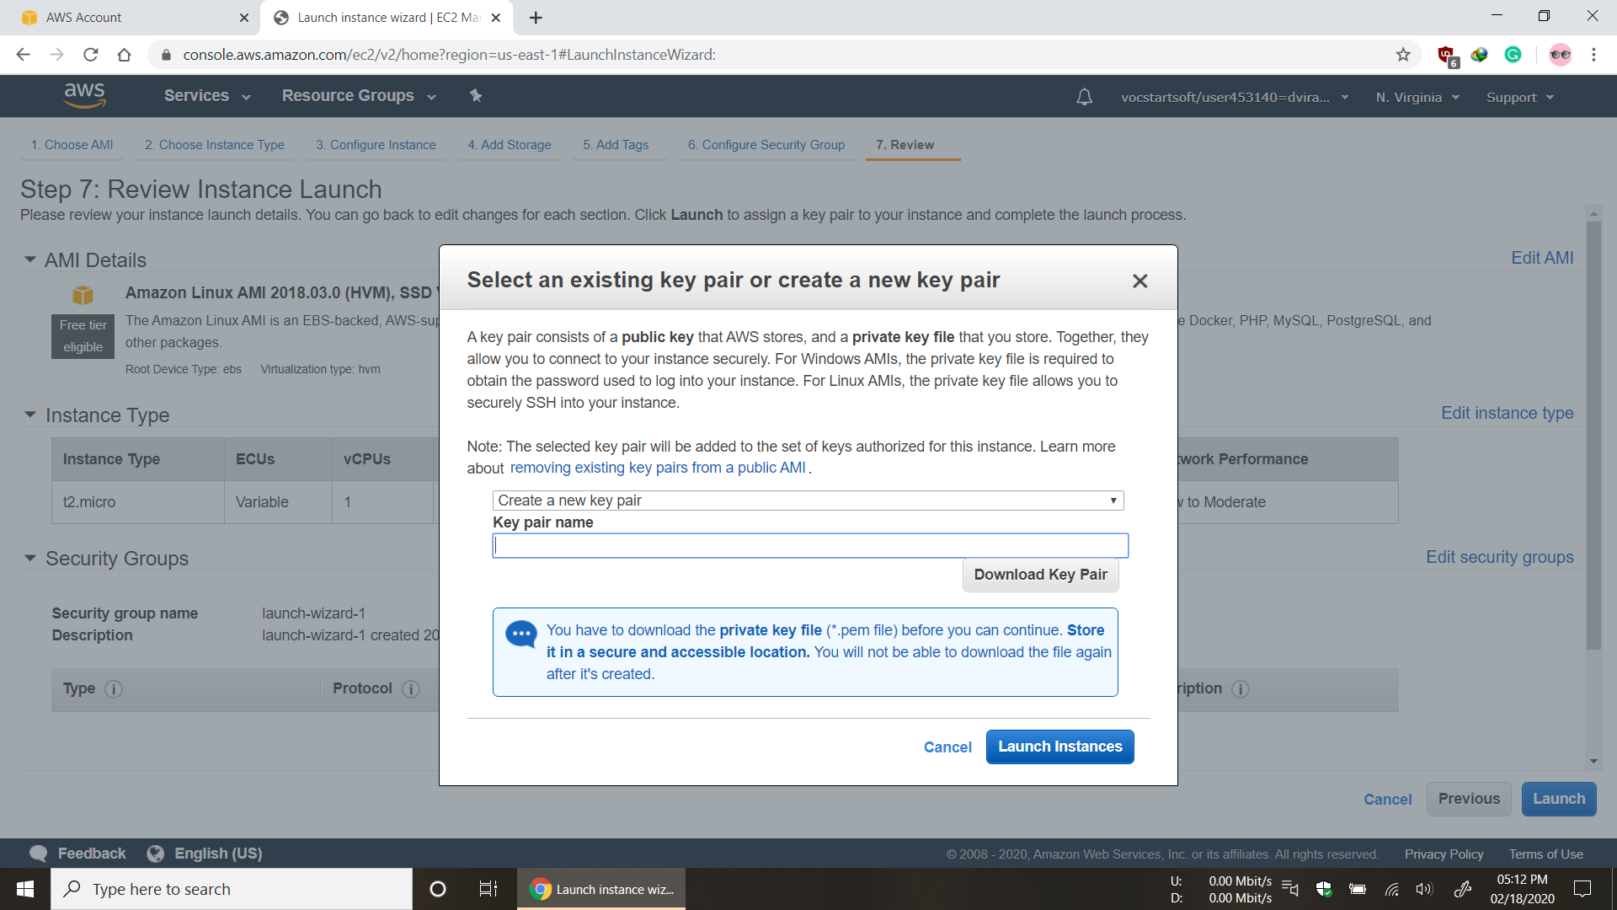

* EC2 Instance is Ready

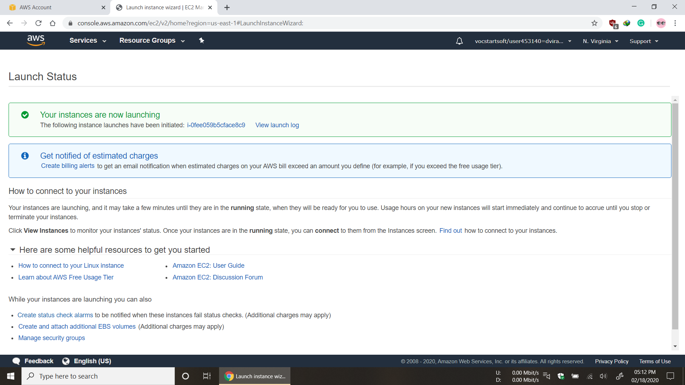

**Step for Accessing Amazon EC2 Instances (Using AWS Command Line Interface)**

* Now, configuring AWS Access key id and Secret access key by executing following command and filling the prompted details.

$ aws configure

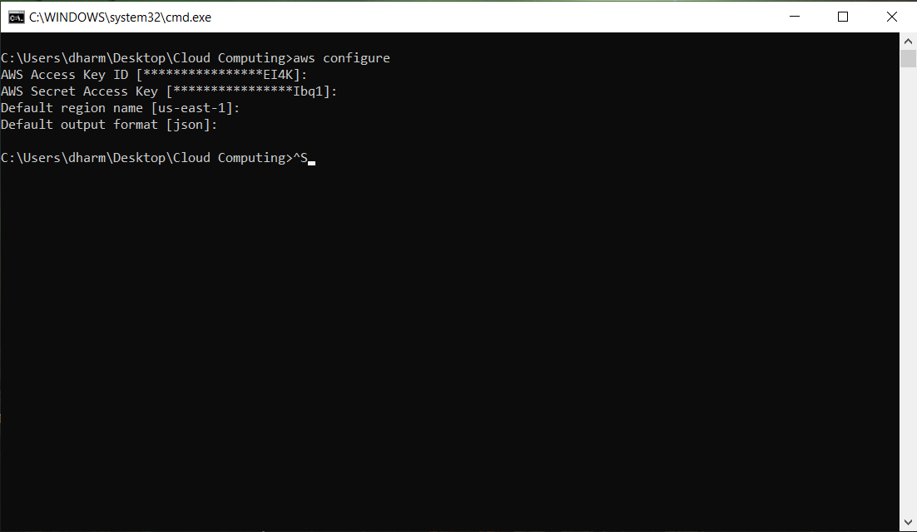

* Now, creating a security group by executing the following command

$ aws ec2 create-security-group --group-name default --description " default VPC security group "

* In this step, you can create a key pair to access aws resources by executing following command. If you already have one then no need to create new key pair. I already have a key-pair, so, I am using that.

$ aws ec2 create-key-pair --key-name ec2@dharmit

* Finally, to create instance using command line interface, we need **Amazon Linux AMI, Security Group Id, Instance Type** and **Key Pair Name**. And then execute the following command to create any number of instances.

$ aws ec2 run-instances --image-id ami-0915e09cc7ceee3ab --security-group-ids default --count 5 --instance-type t2.micro --key-name ec2@dharmit

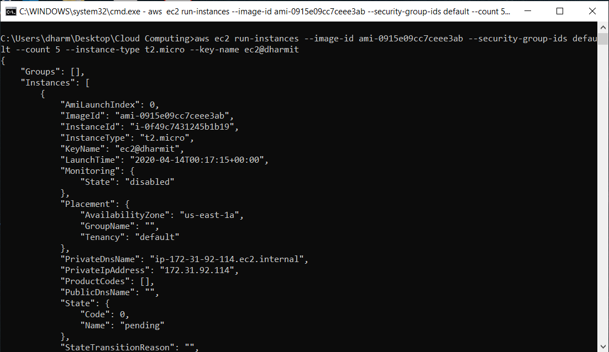

* Now, our 5 instances have been created. I have created five instances in total and named them as Load Balancer, Server 1, Server 2, Server 3, and Server 4.

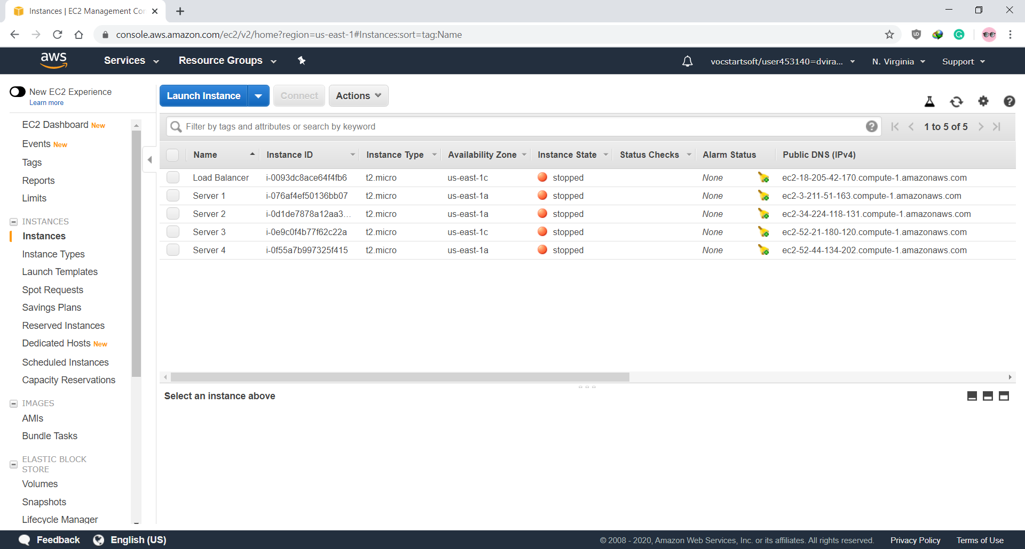

* The last step is to configure the security group for inbound access.

$ aws ec2 authorize-security-group-ingress –-group-name default --protocol tcp –-port 22 –-cidr 71.255.89.254/32

$ aws ec2 authorize-security-group-ingress –-group-name default --protocol tcp –-port 80 –-cidr 71.255.89.254/32

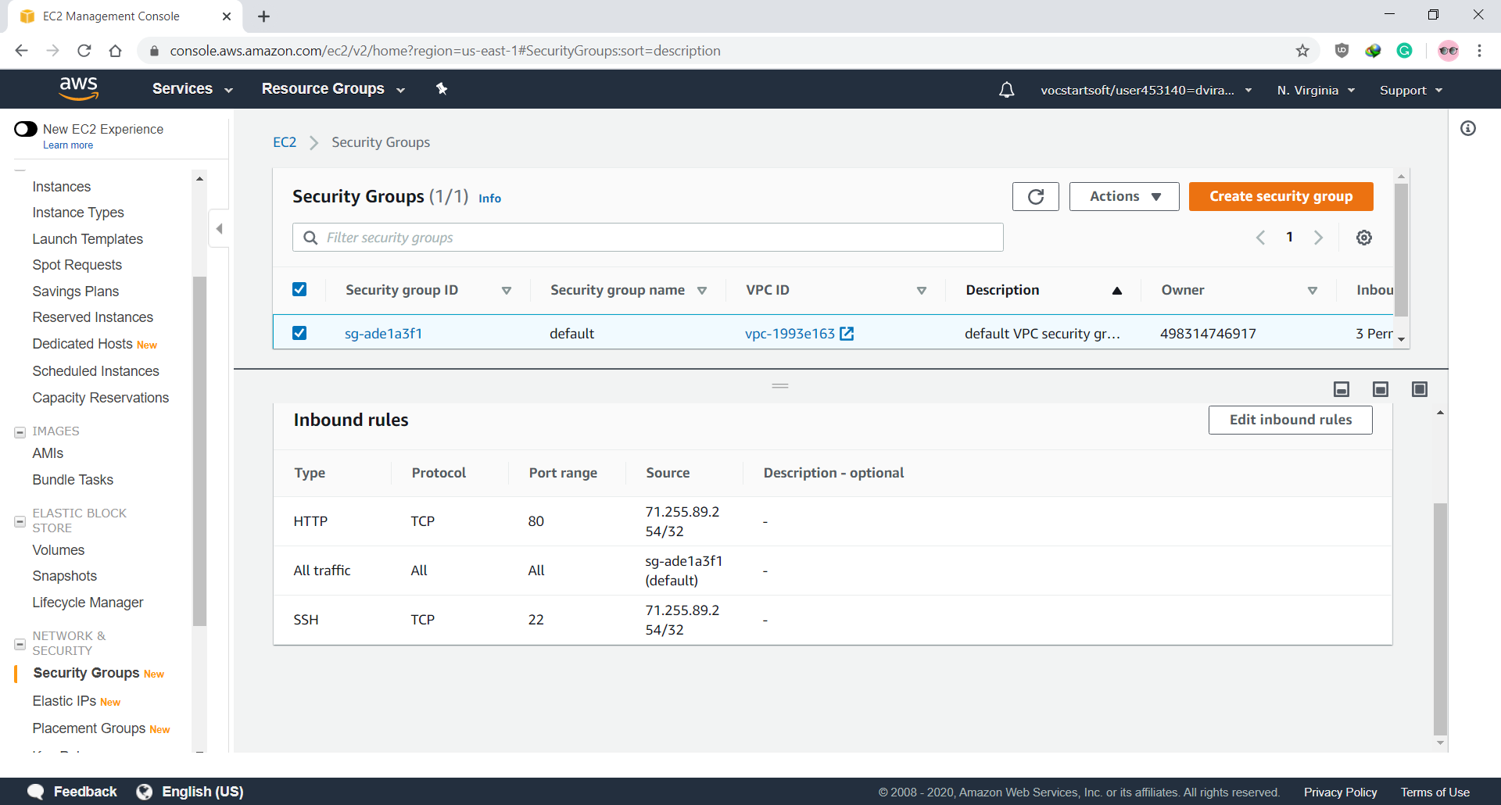

**Step for Accessing AWS instance**

* Now get instances ID by executing following command

$ aws ec2 describe-instances

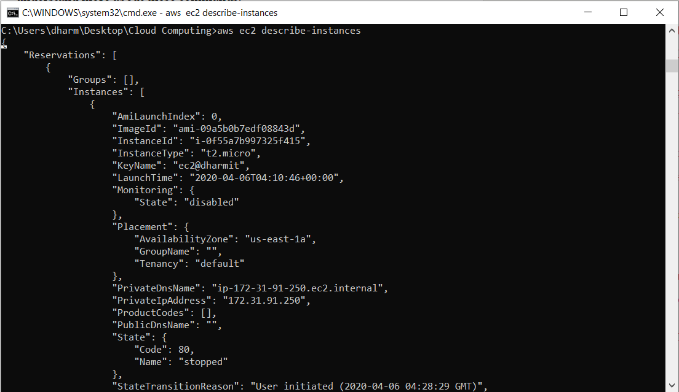

* Start the instances by executing the following command for all the instances by replacing instances id

$ aws ec2 start-instances --instance-ids i-0093dc8ace64f4fb6

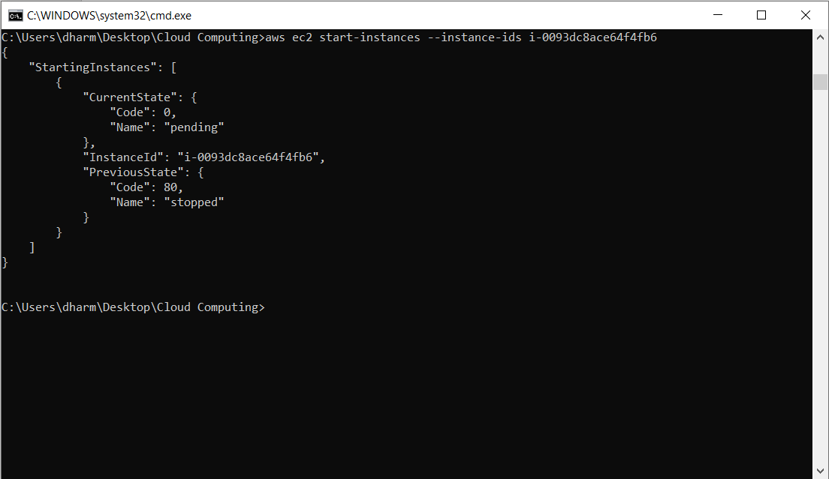

* Establishing connection with EC2 Instance by executing below command

$ ssh -i "ec2@dharmit.pem" [ec2-user@ec2-54-209-75-78.compute-1.amazonaws.com](mailto:ec2-user@ec2-54-209-75-78.compute-1.amazonaws.com)

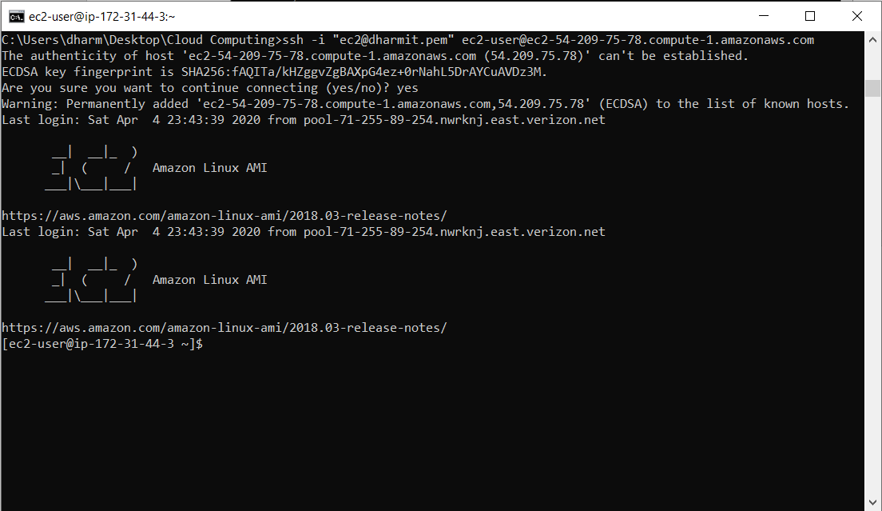

**Steps to install Nginx Server on Amazon EC2 instance**

* After establish a connection with the EC2 instance, installing nginx server on it by executing the below command.

$ sudo yum install nginx

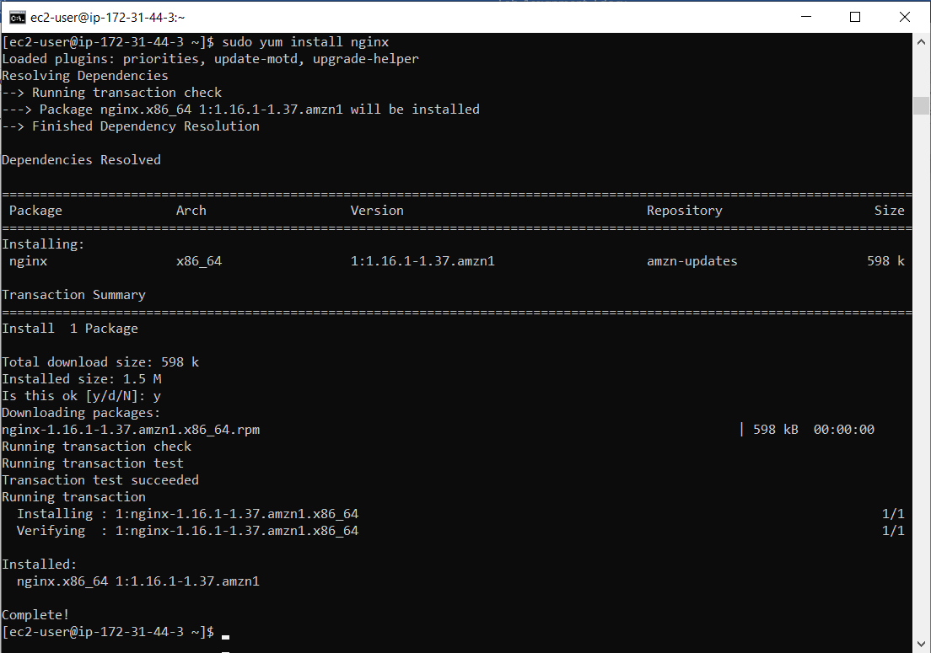

* After installing nginx, starting the services of the nginx by executing

$ sudo service nginx start

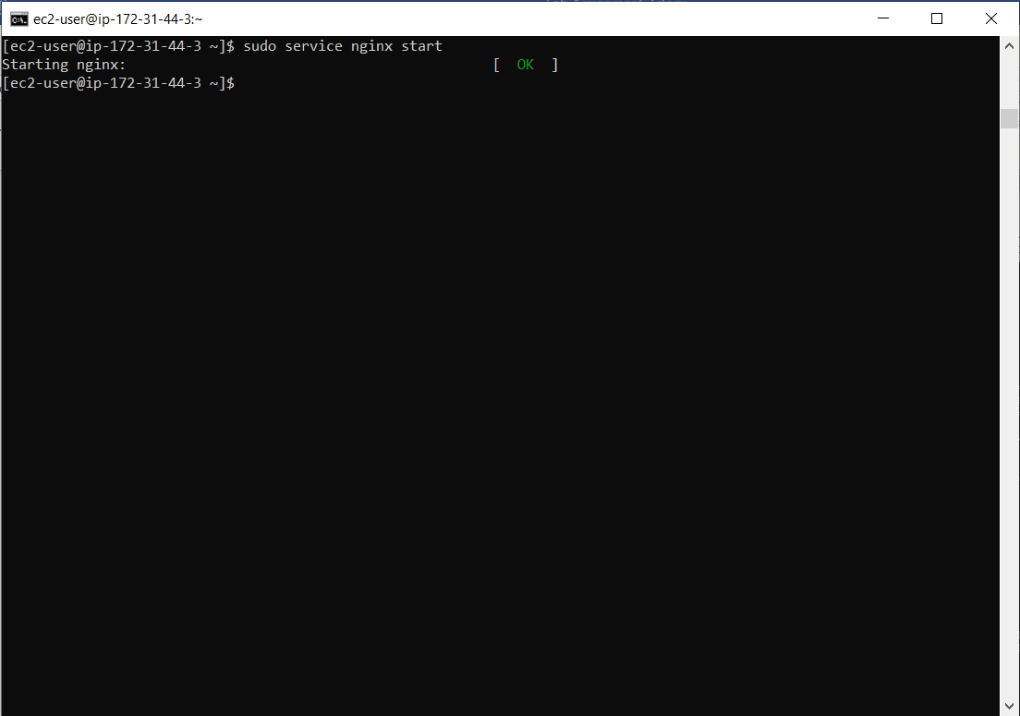

* Testing server by running Public DNS (IPv4) on the browser.

<http://ec2-54-209-75-78.compute-1.amazonaws.com/>

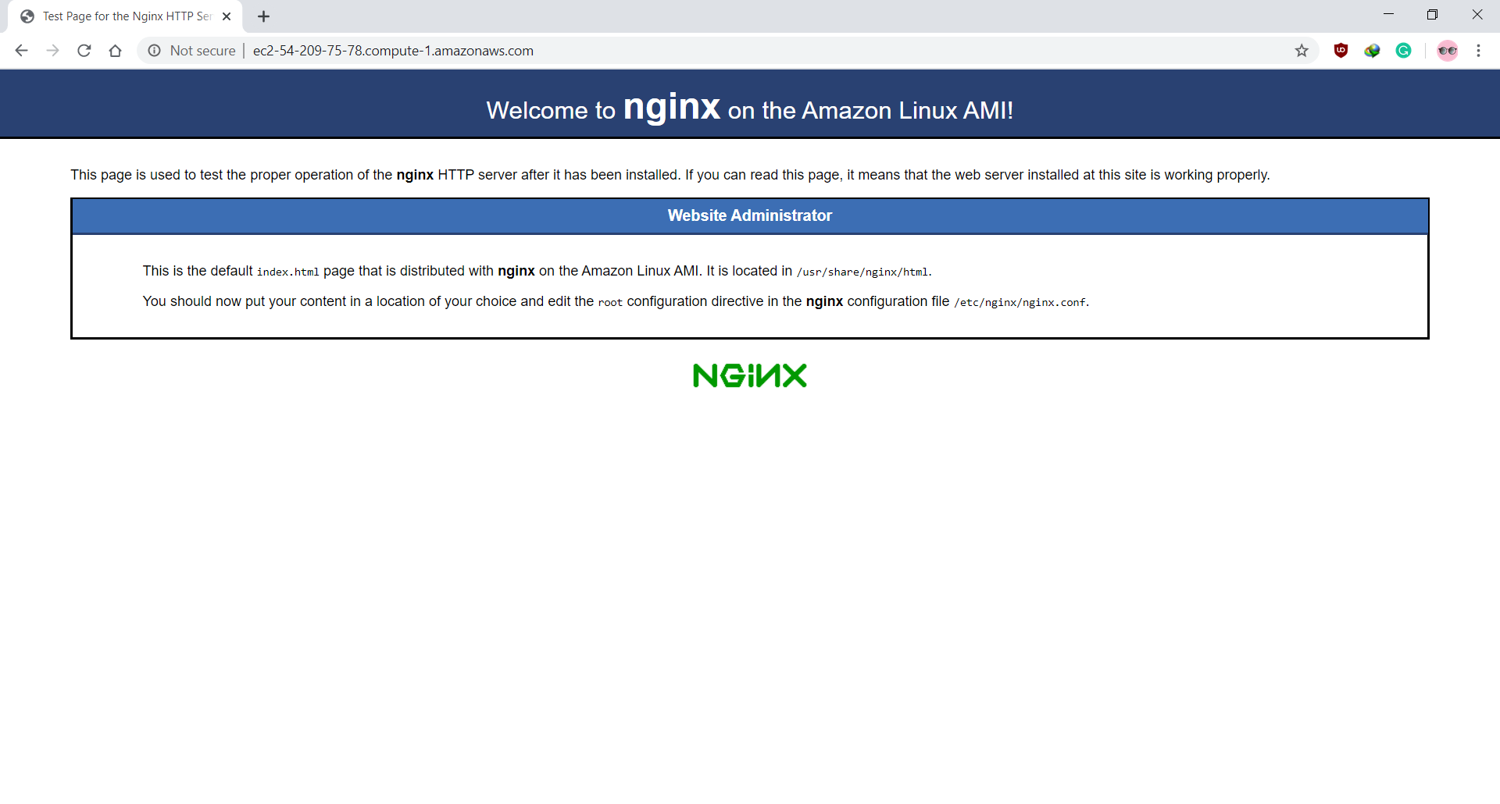

* Now, repeat the same steps to install Nginx Server on each instance you want to install. I have installed the nginx server on each instance i.e. Server 1, Server 2, Server 3, Server 4, and Load Balancer.

**Steps to change nginx server index.html file on Amazon EC2 instance**

* After successfully installing nginx server, navigate to /usr/share/nginx/html directory. To navigate type following command in the terminal window

$ cd /usr/share/nginx/html

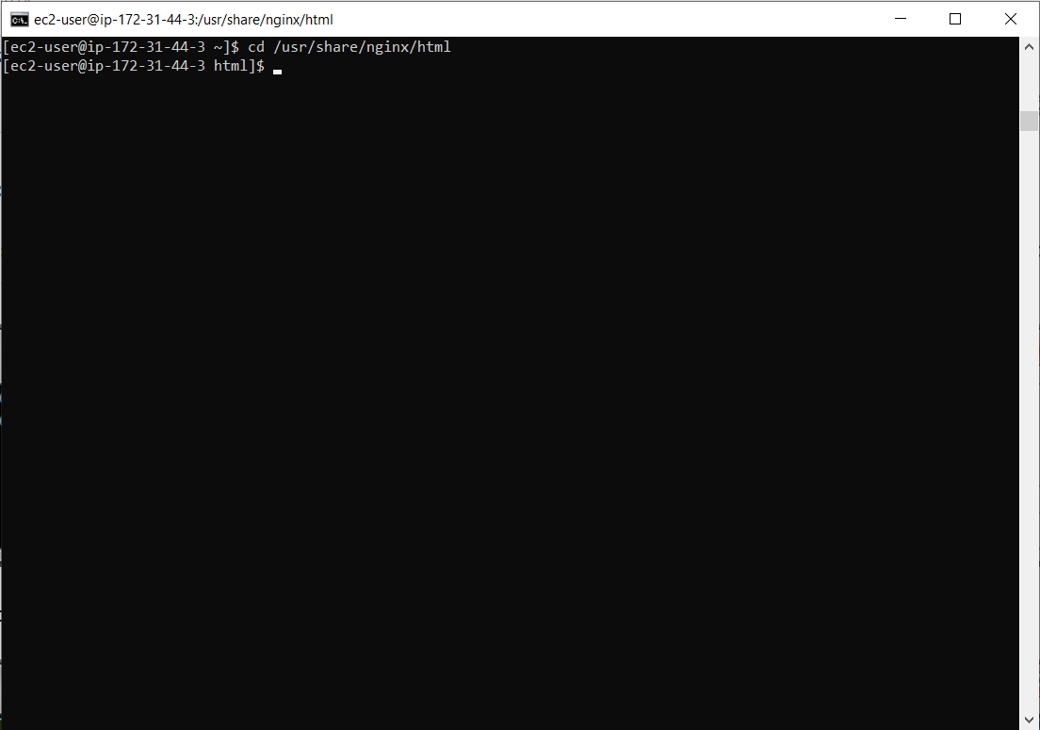

* Then open the index.html file in vim. To open type following command in the terminal window

$ sudo vim index.html

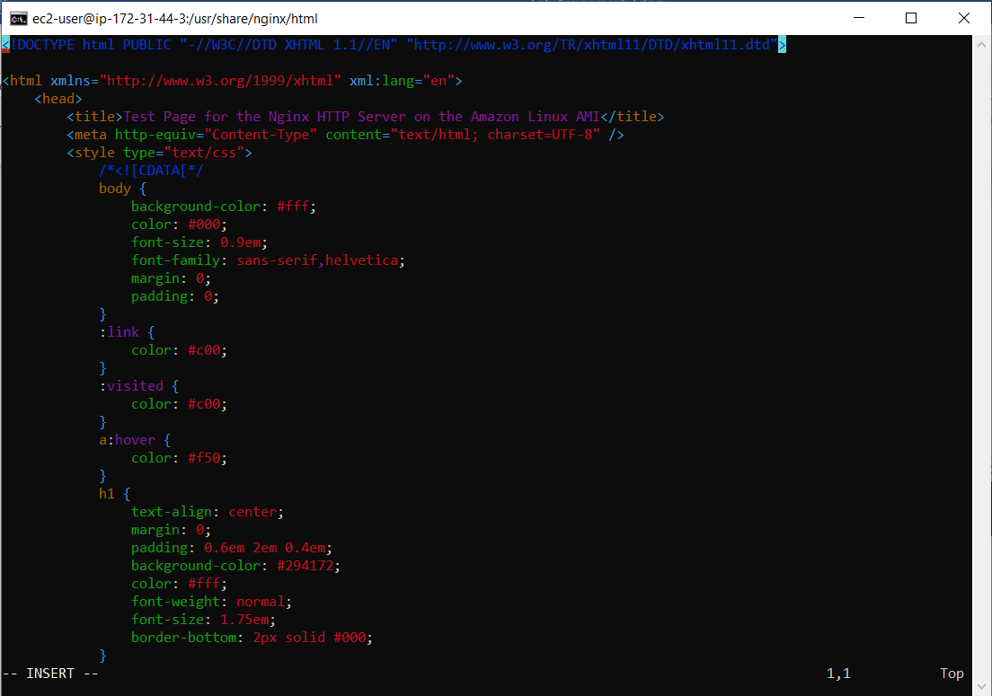

* Editing the index.html file for Server 1 or instance number 1.

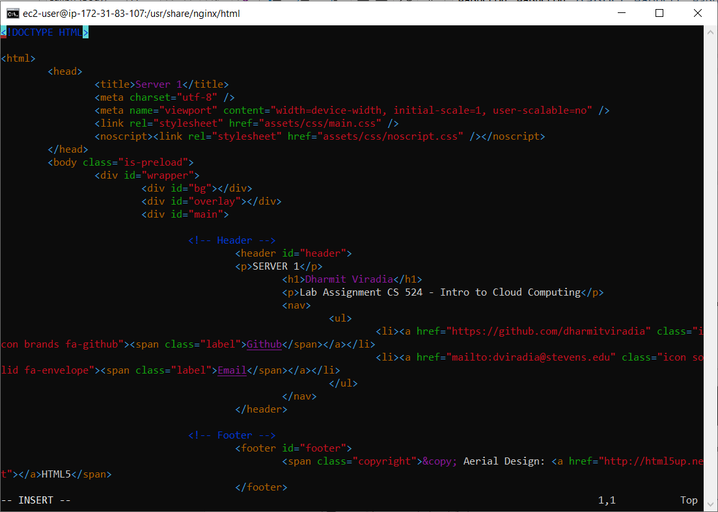

* Actual page on browser after editing index.html file over AWS EC2 for “Server 1” or Instance number 1.

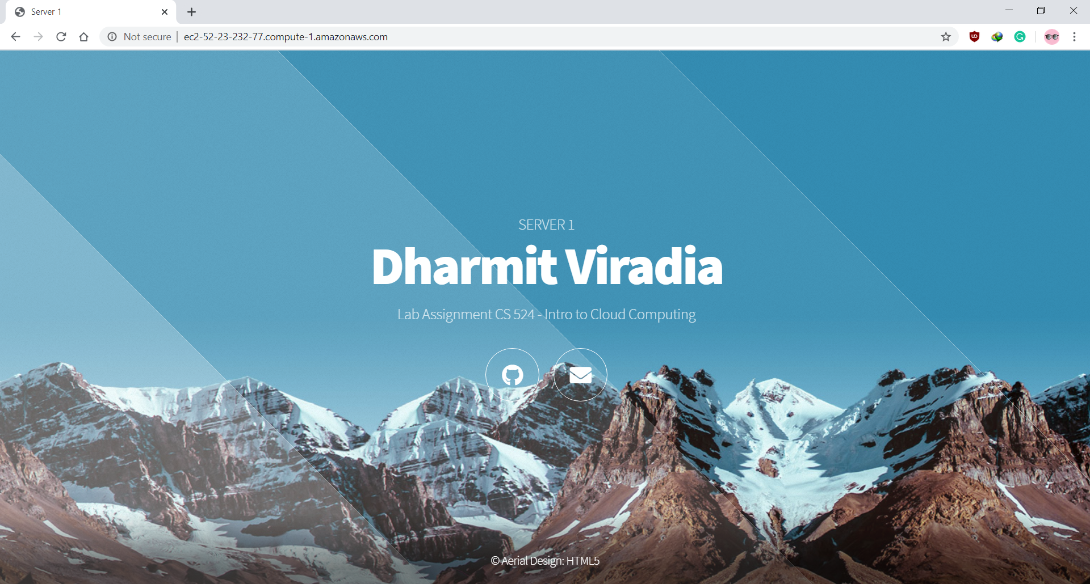

* Now, repeat the same steps to edit the index.html file on each instance you want. I have edited the index.html file for all my four instances i.e. Server 1, Server 2, Server 3, and Server 4.
  + - Server 1

<http://ec2-3-211-51-163.compute-1.amazonaws.com/>

<http://3.211.51.163/>

* + - Server 2

<http://ec2-34-224-118-131.compute-1.amazonaws.com/>

<http://34.224.118.131/>

* + - Server 3

<http://ec2-52-21-180-120.compute-1.amazonaws.com/>

<http://52.21.180.120/>

* + - Server 4

<http://ec2-52-44-134-202.compute-1.amazonaws.com/>

<http://52.44.134.202/>

(Note, we can also edit index.html file of the Load Balancer instance. But there would be no use of modifying it, because whenever you try to hit/visit a public IP or DNS of Load Balancer, it would redirect you on one of the servers it is dealing with in my case it would redirect to one of the above servers. In next step, we will be handling this amazing feature of Load Balancer, and observer how it works to balance the load by redirecting to one of its servers.)

**Steps to configure Load Balancer on Amazon EC2 instance**

* First to configure the Load Balance, connect to Load Balance instance. Then navigate to /etc/nginx/ by executing the following commands in the terminal.

$ ssh -i "ec2@dharmit.pem" [ec2-user@ec2-18-205-42-170.compute-1.amazonaws.com](mailto:ec2-user@ec2-18-205-42-170.compute-1.amazonaws.com)

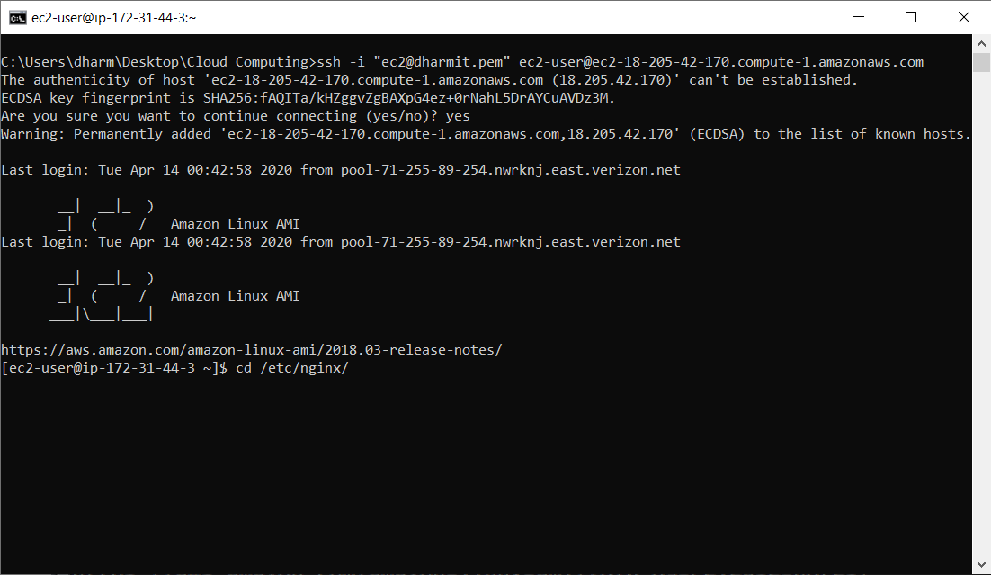

$ cd /etc/nginx/

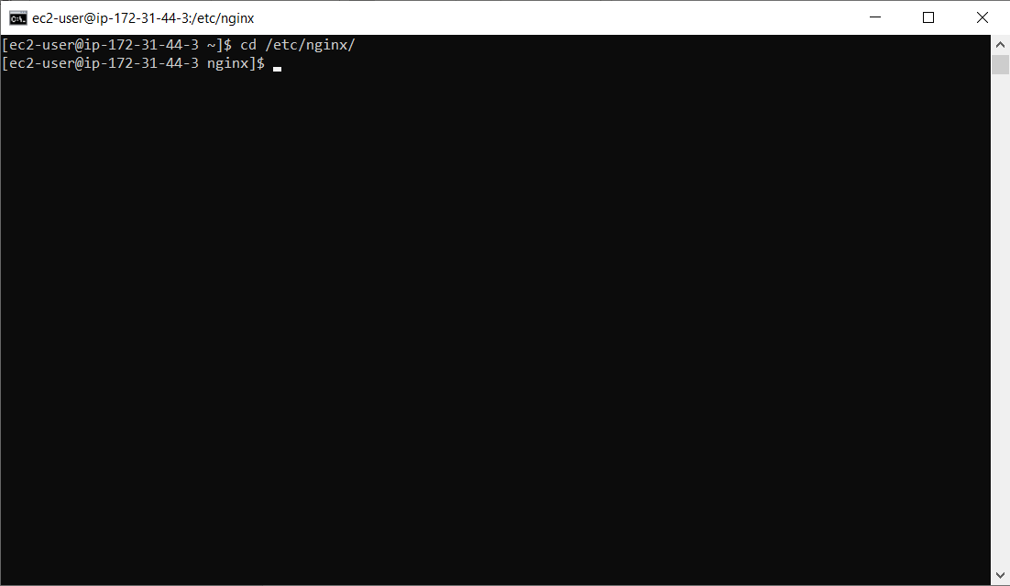

* Now open nginx.conf using vim by executing following command

$ sudo vim nginx.conf

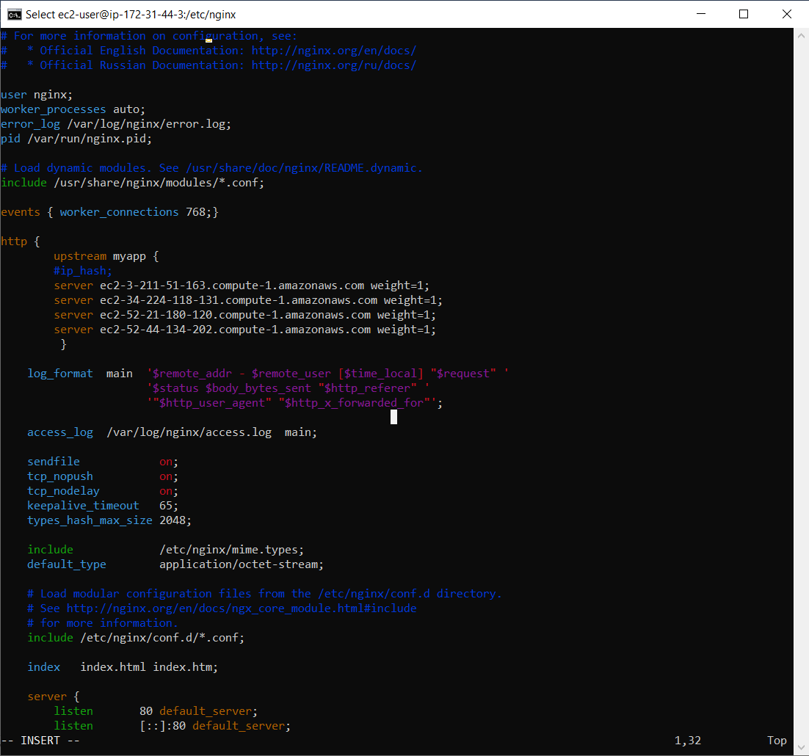

Now editing file by adding and replacing code by following codes events

{

worker_connections 768;

}

http {

upstream myapp {

#ip_hash;

server [SERVER_PUBLIC_DNS_NAME] weight=1;

server [SERVER_PUBLIC_DNS_NAME] weight=1;

server [SERVER_PUBLIC_DNS_NAME] weight=1;

server [SERVER_PUBLIC_DNS_NAME] weight=1; }

server {

listen 80;

server_name myapp.com;

location / {

proxy_pass <http://myapp>;

}

}

}

(**Note**: SERVER_PUBLIC_DNS_NAME would be replaced by your instance Public DNS)

* Now, run the following command in the shell (this will cause the new configuration to take effect):

$ /etc/init.d/nginx reload

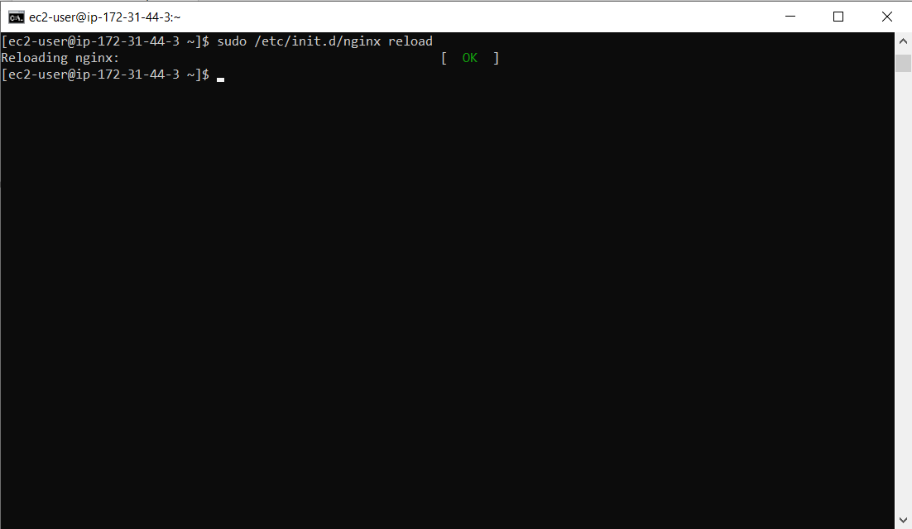

* Now, we have to use the curl command in the shell to visit the load balancer, which will distribute traffic among their servers.

$ curl ec2-18-205-42-170.compute-1.amazonaws.com

Server 1

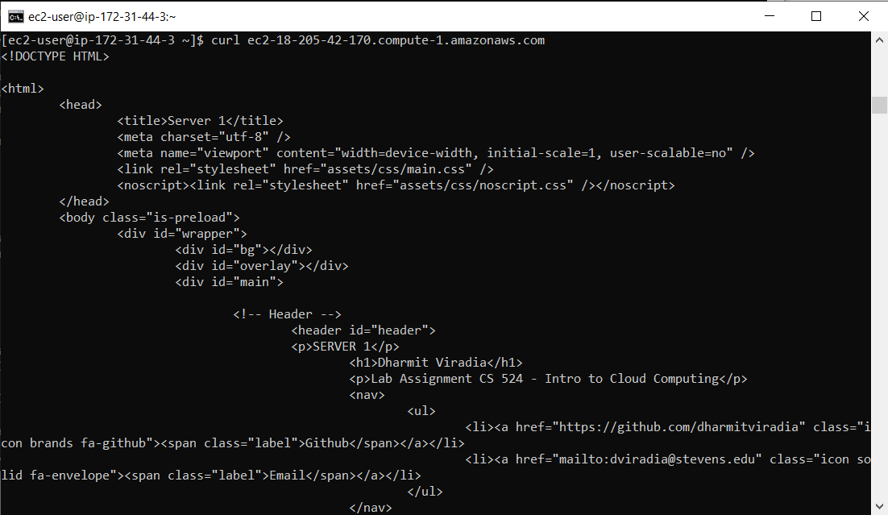

Server 2

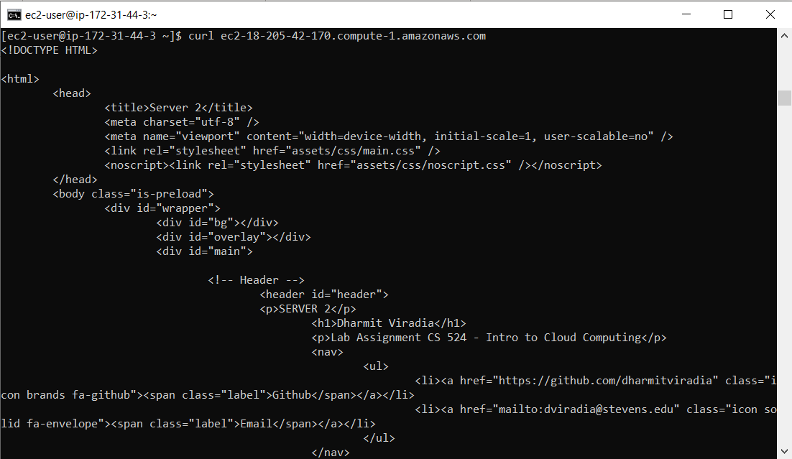

Server 3

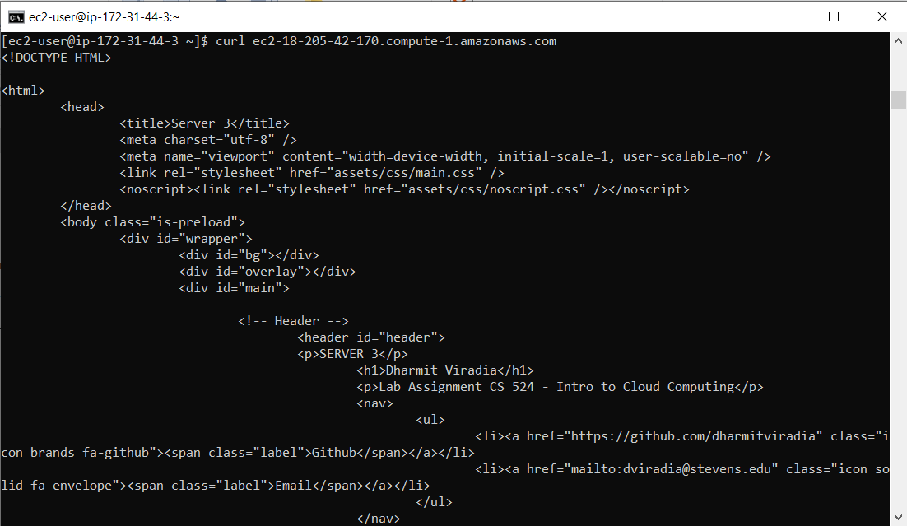

Server 4

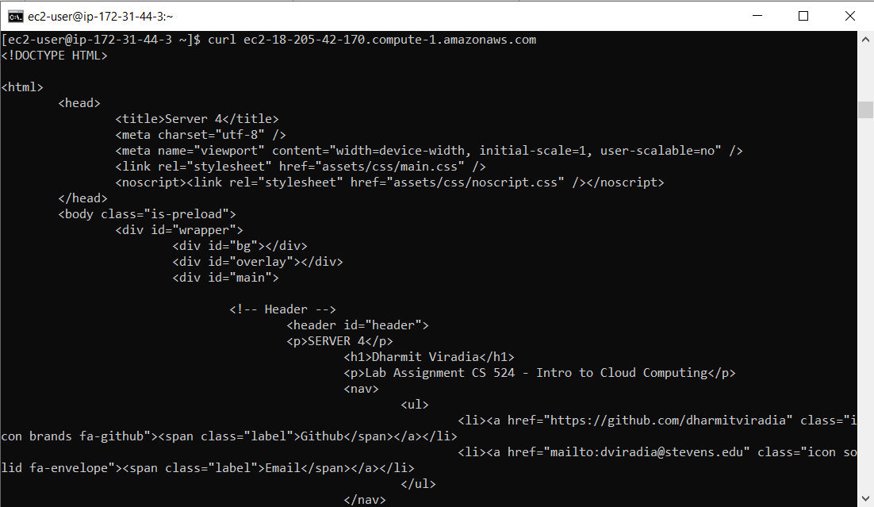

(**Notice** that on each curl command, the load balancer is distributing traffic to each server sequentially)

**Steps to collect information on visits to your website using Amazon EC2 instance**

* Setting up Visit Server tool to track the distribution of the load. This tool visits the cluster 2000 times and returns the visit count on each server

$ cd /usr/bin

$ vim visit_server

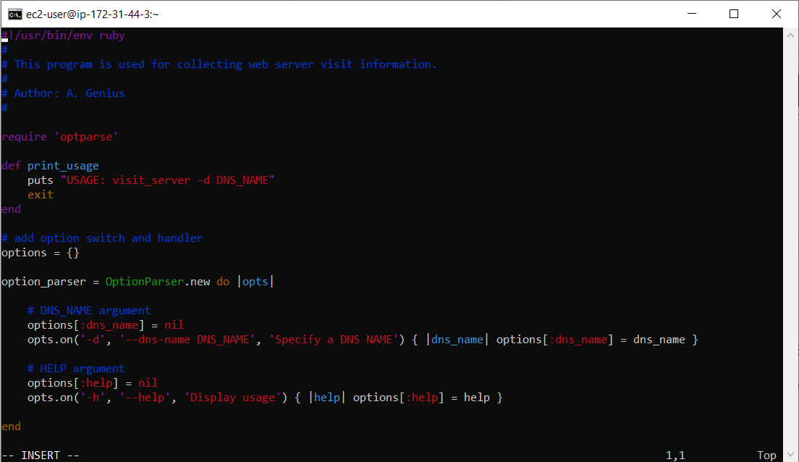

* Now, we will trace the load balancing server load distribution for 3 scenarios by changing the server weight in the nginx.conf file
  + - Scenario #1 – Server1 weight=1, Server2 weight=1, Server3 weight=1, Server4 weight=1
    - Scenario #2 – Server1 weight=1, Server2 weight=2, Server3 weight=3, Server4 weight=1
    - Scenario #3 – Server1 weight=1, Server2 weight=2, Server3 weight=1, Server4 weight=2
* Tracing load balancer for

Scenario #1 – Server1 weight=1, Server2 weight=1, Server3 weight=1, Server4 weight=1

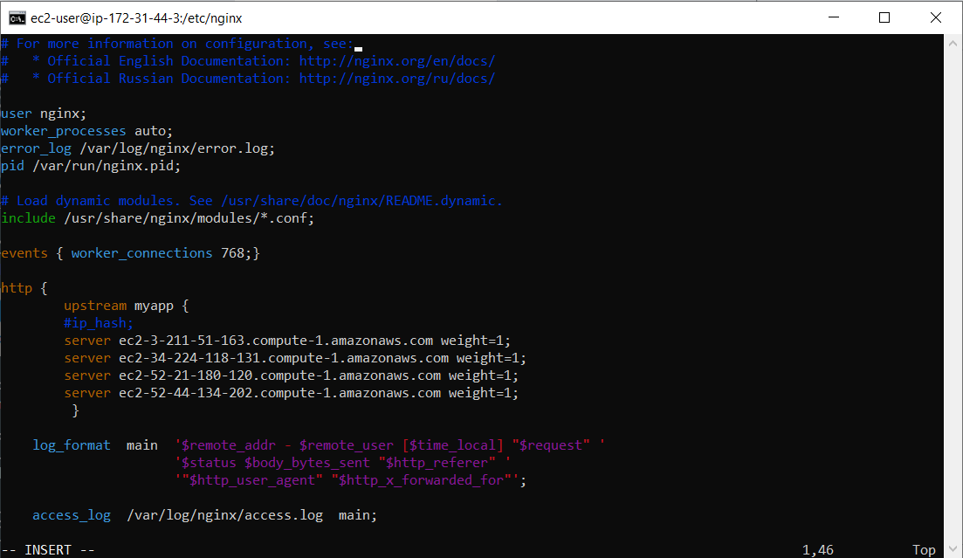

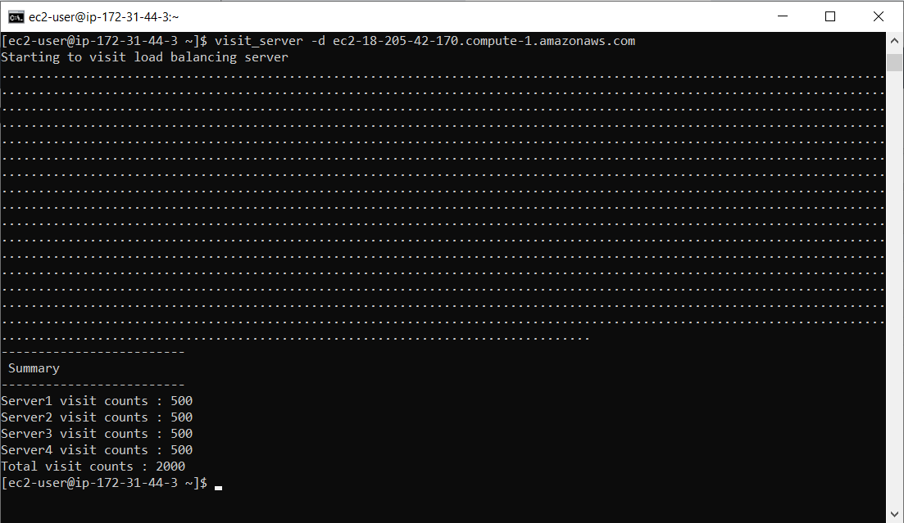

* Tracing load balancer for

Scenario #2 – Server1 weight=1, Server2 weight=2, Server3 weight=3, Server4 weight=4

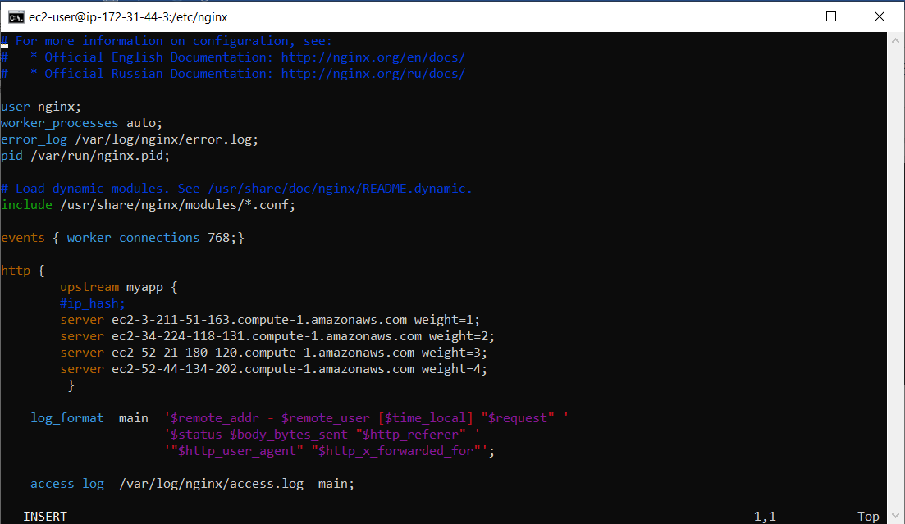

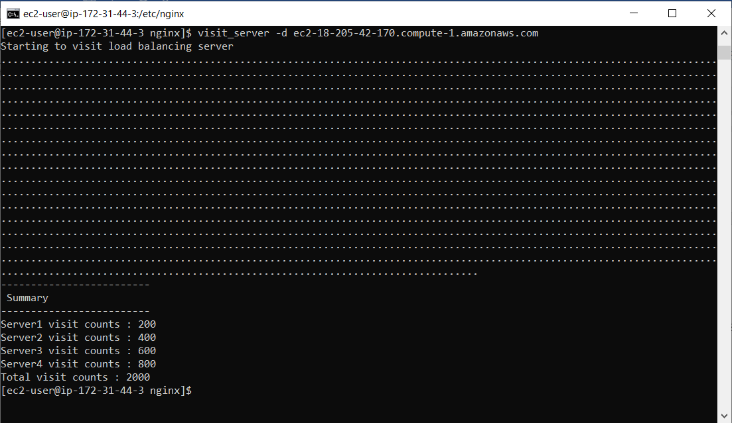

* Tracing load balancer for

Scenario #3 – Server1 weight=1, Server2 weight=2, Server3 weight=1, Server4 weight=2

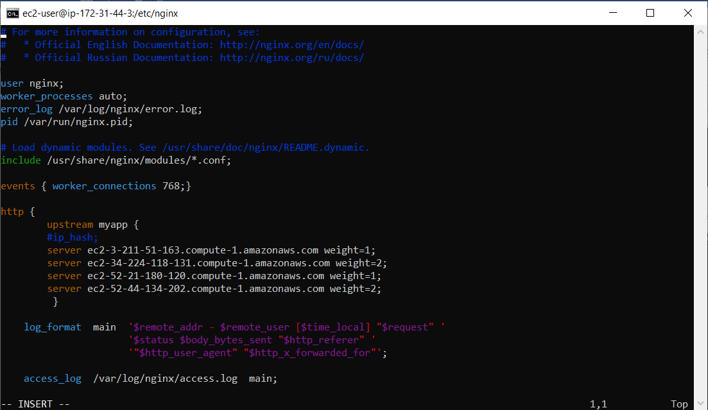

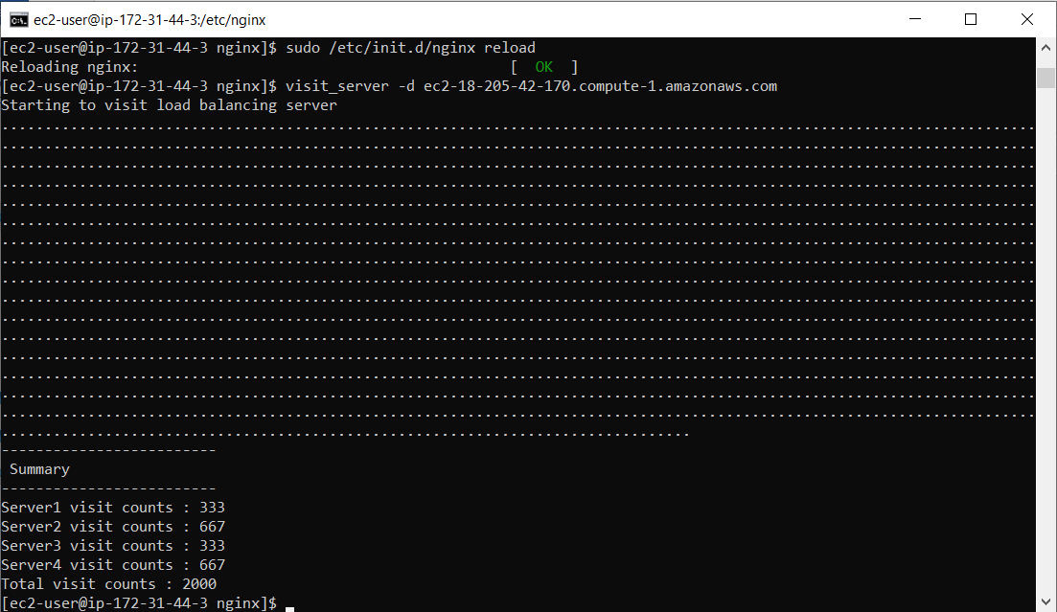

**Steps to tcpdump Analysis using Amazon EC2 instance**

* Installing tcpdump packages

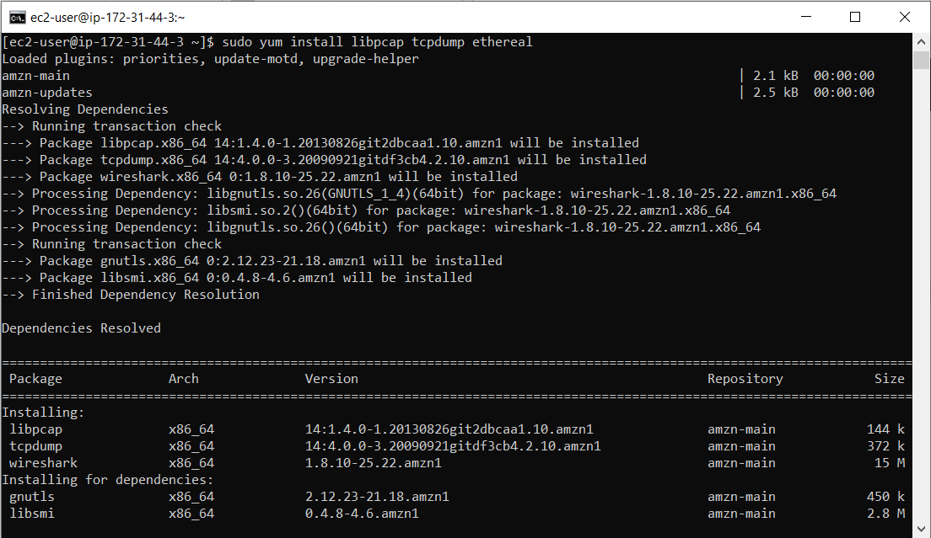

* Running tcpdump command first time and creating report in dumpfile.txt file

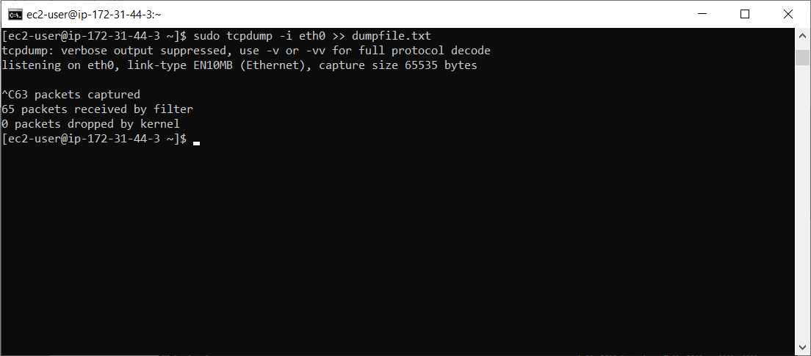

* tcpdump data is logged into dumpfile.txt

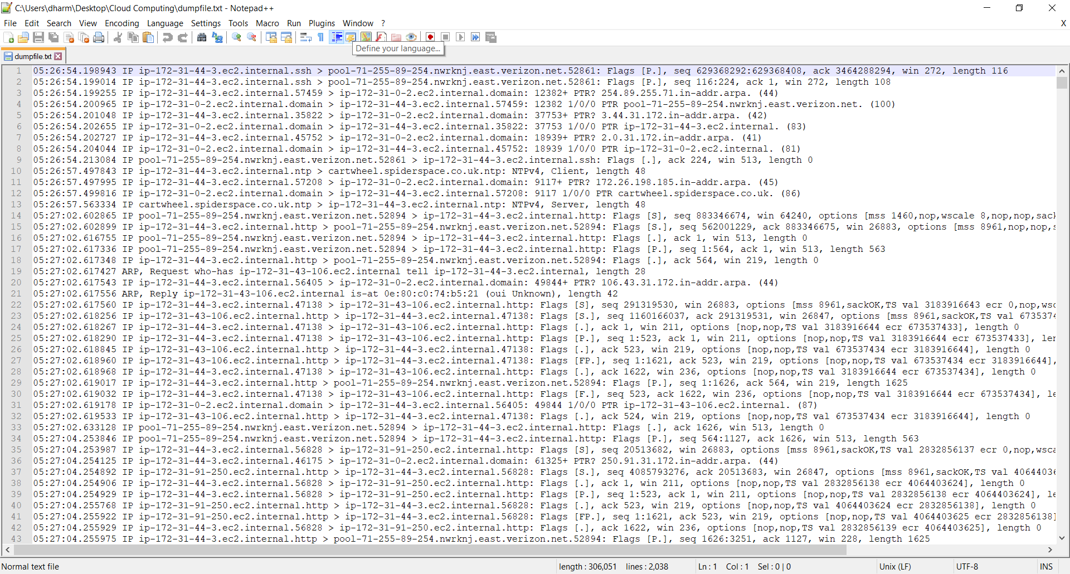

* When we analyze the file contents, we see the first few lines being sent by the remote host to my desktop. Then the remote host issues an ARP request to get its own mac address. Since I had made a http request to the load balancer while tcpdump was running (on the load balancer), there are packet information from my local desktop to the load balancer, then from the load balancer to one of the servers, and finally back all the way to my local desktop.

**Steps to Backup and Restore Volume on Amazon EC2 instance**

* Creating snapshot of existing volume

$ aws ec2 create-snapshot --volume-id vol-01bbd0a68eef4638c --description “Load Balancer Snapshot”

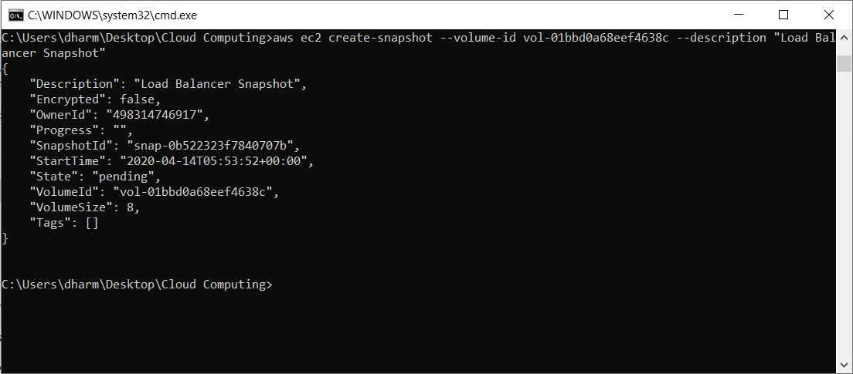

* Stopping the instance to detach the volume

$ aws ec2 stop-instances --instance-ids i-0093dc8ace64f4fb6

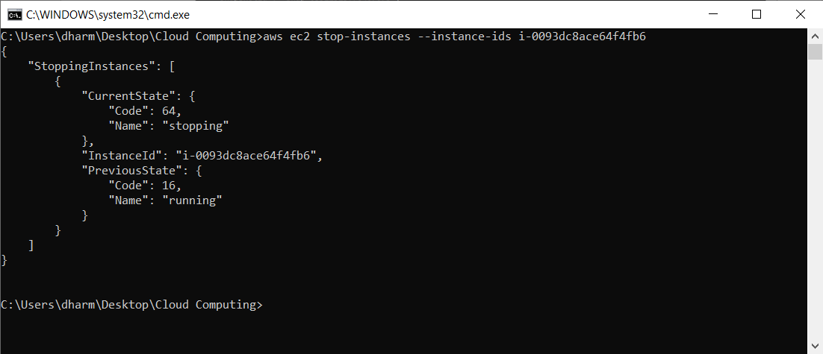

* Detaching the volume

$ aws ec2 detach-volume --volume-id vol-01bbd0a68eef4638c

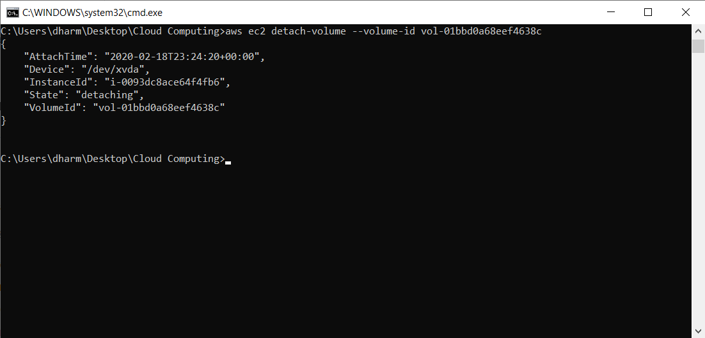

* Creating new EC2 instance

$ aws ec2 run-instances --image-id ami-0915e09cc7ceee3ab --security-group-ids default --count 1 --instance-type t2.micro --key-name ec2@dharmit

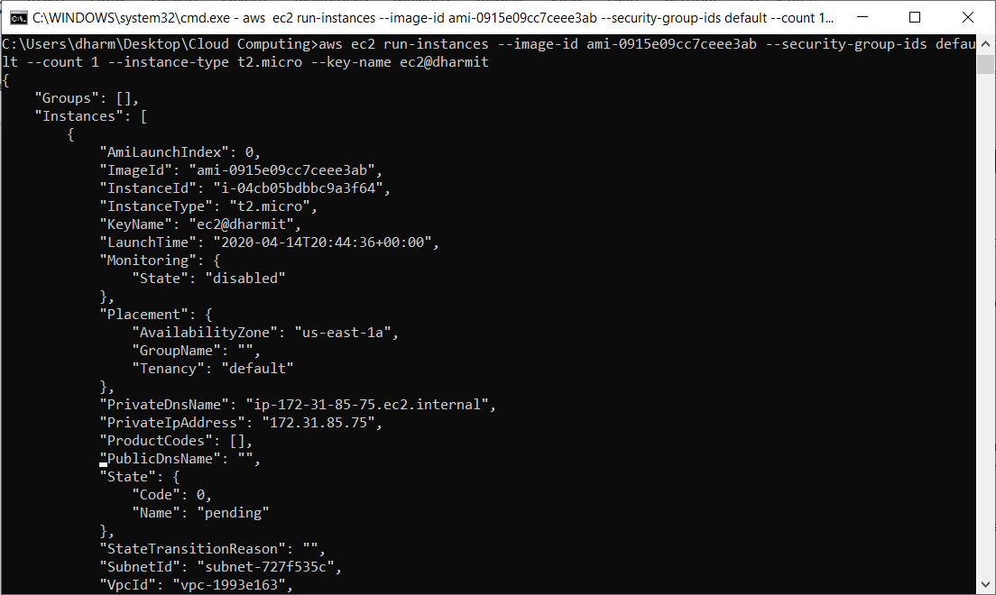

* Stopping the new created instance to detach the volume

$ aws ec2 stop-instances --instance-ids i-04cb05bdbbc9a3f64

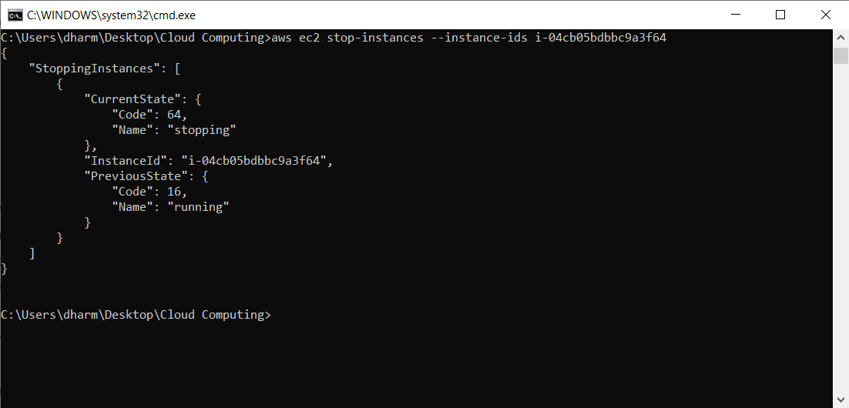

* Detaching the volume on new instance

$ aws ec2 detach-volume --volume-id vol-0e746efbf89345e44

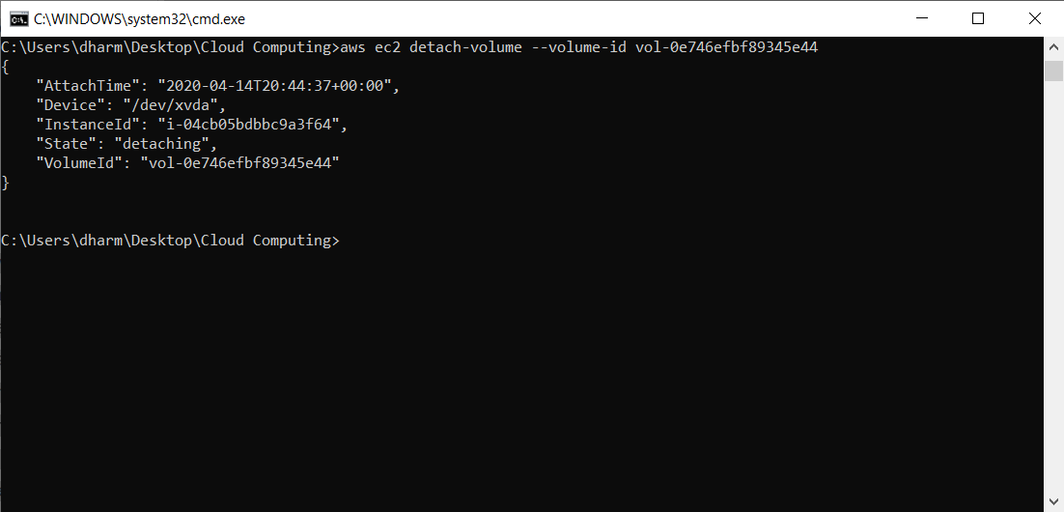

* Attaching the previously detached volume to the new instance

$ aws ec2 attach-volume --volume-id vol-01bbd0a68eef4638c --instance-id i-0046dc440e2215b76 --device /dev/xvda

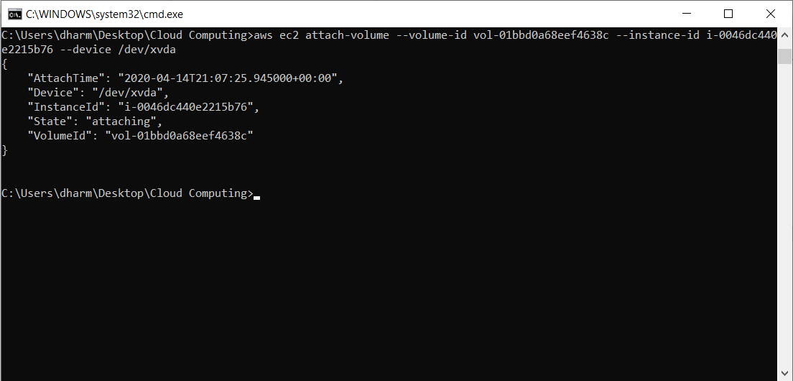

* Starting the new instance

$ aws ec2 start-instances --instance-ids i-0046dc440e2215b76

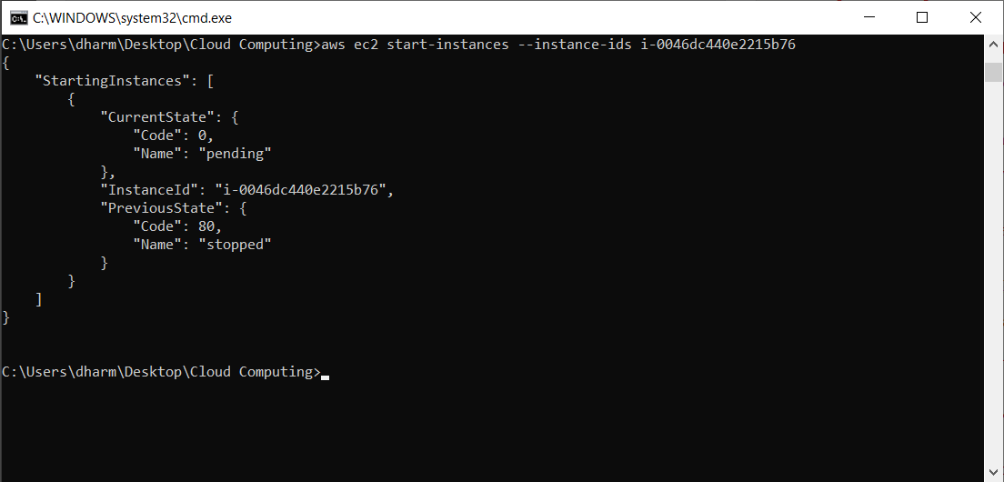

* Connecting to the new instance

$ ssh -i "ec2@dharmit.pem" ec2-user@ec2-54-89-120-136.compute-1.amazonaws.com

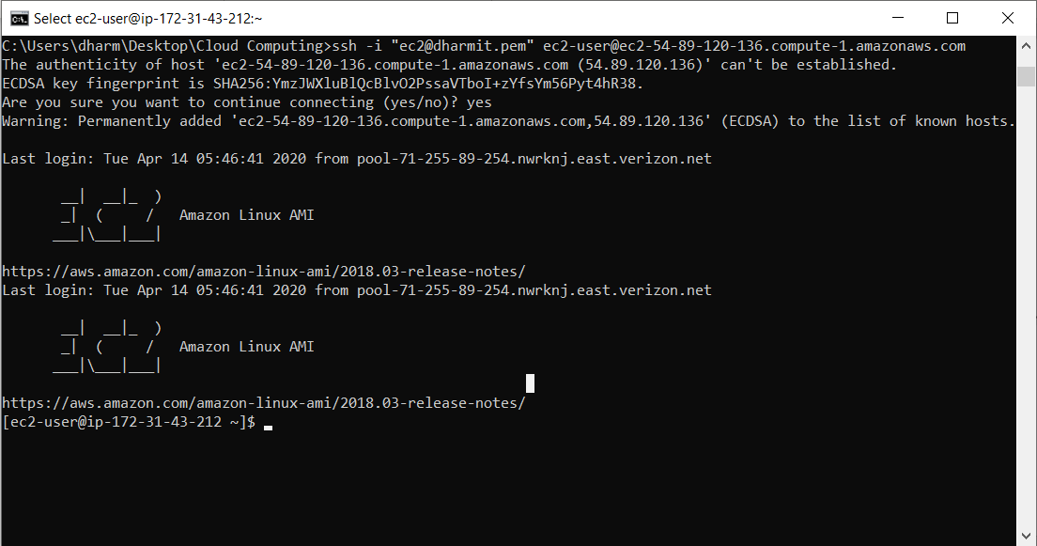

* Starting the nginx on the new instance

$ sudo service nginx start

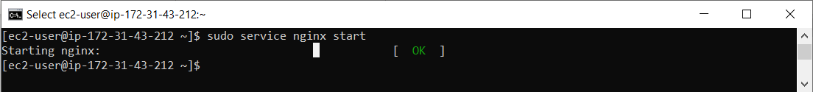

* Server running on new instances

